|  |  |  |
| --- | --- | --- |
| **Stage** | **Description** | **Activities and Artifacts** |
|  | Discover architectural  drivers | Interact with stakeholders to discover and document the raw architectural drivers. |
|  | Establish project scope | Refine raw architectural drivers into an architectural drivers specification, and define the scope of the work. |
|  | Create/refine architecture | Create or refine the architecture design. After initial design the architect (or architecture team) will return to this step after experimentation (stage 7) to refine the architecture. |
|  | Architectural review | Review the architecture to discover and document issues that may compromise the satisfaction of the architectural drivers. |
|  | Production go/no-go | Prioritize and list the issues discovered during the architecture review and decide whether the architecture is ready for production or needs to be refined. If a go decision is made, the team goes to stage 8; otherwise, the team will experiment to refine the architecture. |
|  | Experimentation | Team designs and plans experiments to mitigate risks or issues that were discovered during the review to alleviate issues uncovered during the architecture review. Once planned, the team carries out the experiments and documents the results. Based on the results of the experiments, the team refines the  architecture (stage 3) design base |
|  | Production planning | The detailed element design and construction is planned based on the architecture design. |
|  | Production | The system elements are constructed |

Quality process engineer: The quality process engineer ensures that ACDM and other defined processes are followed as prescribed to ascertain project quality goals are met. The quality process engineer is responsible for coordinating architecture design reviews as well as product test development, planning, and execution. The quality process engineer will work with the requirements engineer and the chief scientist to coordinate the architecture design reviews and in planning product or system tests. During architectural reviews, the quality process engineer is responsible for capturing, documenting, and tracking architectural issues uncovered during architectural evaluation, and that they are addressed and closed. The quality process engineer will also work with the team to establish the processes for configuration management, defect tracking, and so forth that the design team uses. These processes may also be used by the detailed designers or implementers throughout the production stage and for the life cycle of the system or product as well.

Another separation of concerns has been built into the area of architectural review and system test. These responsibilities are distributed among the quality process engineer (QPE), the chief scientist (CS), and the requirements engineer (RE). The QPE is responsible for test and evaluation but must work with the RE and CS to develop test plans and coordinate the architecture design reviews. This approach helps maintain objectivity in test and design reviews. From a test perspective, this separation of concerns allows the team to test the system from the stakeholder requirements and technical internal perspectives. The QPE is a neutral party from a technical standpoint. The RE contributes to test planning from the stakeholders’ perspective. This is black-box testing in the ACDM context, where the system is treated as a black box and is tested only with respect to compliance with the architectural drivers—those of stimulus and response without internal insight. However, the chief scientist has insight into those potentially risky and problematic technical elements of the system that should be exercised through test. This is clear-box testing in the ACDM context. This separation of concerns addresses system testing objectively, inwardly (clear-box test), and outwardly (black-box test). To summarize these roles, the quality process engineer is responsible for coordinating design reviews and tests; the requirements engineer focuses outwardly on tests from the requirements standpoint; and the chief scientist focuses inwardly on testing

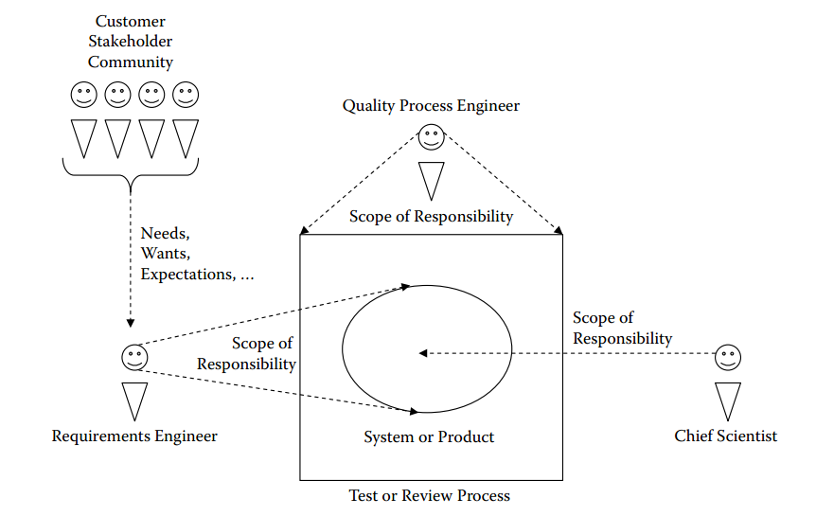

**ACDM Stage 4: Evaluate the Architecture Design**

Mục đích chính của giai đoạn 4 là cho team thiết kế kiến ​​trúc đánh giá thiết kế kiến ​​trúc ban đầu, hoặc tái thẩm định thiết kế được xác định sau khi đánh giá kiến trúc và thử nghiệm.

**Pre-condition**

Trước khi thực hiện giai đoạn 4 thiết kế kiến ​​trúc (Architecture Design) phải được hoàn thành đầy đủ để thuận lợi cho việc thẩm định thiết kế. Tối thiểu cần có thiết kế kiến trúc, tài liệu thể hiện 3 view (physical, static, dynamic) kèm theo lý do.

**Techniques, Templates, and Guidance**

* Evaluation planning templates
* Evaluation guidance
* Issue recording template

**Primary Artifacts**

The primary artifact is a list of issues (issue recording template) resulting from the evaluation

**Post-condition**

Architecture design is evaluated and key issues identified and documented

